Incubation Proposal
[Name of the company]

[Address of the Company or of the Entrepreneur]

Author:
Date:
Reference: XXXX, Issue XXXX Version XXXX

TABLE OF CONTENTS
1. Activity Proposal 3
1.1 Milestone Planning 3
1.2 Task Descriptions 3
2. Management & Work Logic 4
3. Funding Request 4
4. Support Request 5
4.1 Technical Support 5
4.2 Business Support 5
4.3 Office Support 5

Before each paragraph, you will find “writing tips”. Please use these questions as guidelines. These tips shall be deleted before the submission of the document.

Please limit this Incubation Proposal to maximum 10 pages excluding cover page and excluding the table of contents.

1. Activity Proposal

1.1 Milestone Planning

Writing Tips: Please provide an overview on the schedule including a planning of the milestones (Kick-Off, Mid Term Review and Final Review). The maximum duration of the incubation is 24 months. For this, please use the PLAN table contained in the Excel file attached to this application package (RD.6). Note, all Tasks defined in this planning have to be specified below. Should you prefer to aggregate months, please do so using quarters (Q1, Q2, etc.).

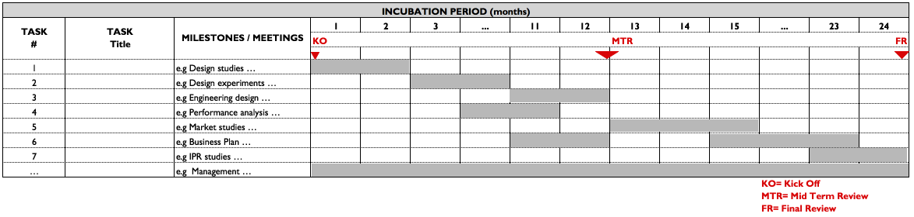

Fig. X: Milestone Planning [example]

Text

1.2 Task Descriptions

Writing Tips: Please provide for each Task one table containing detailed tasks description. Provide for each task the responsible person, input, objectives and output with a detailed description of the activities. Please limit yourself to a manageable Task structure and use Sub-tasks to detail the activities further.

Task [#] | [Task name] | Start: e.g. M1 | End: e.g. M24
Inputs: | [E.g. output of previous Tasks, results of a tests campaign, reference of publication]
Objectives: | [Description]
Sub-tasks:
Sub-Task 1: | [Description]
Sub-Task 2: | [Description]
Sub-Task n: | [Description]
Output: | [e.g. Design Document, Software, Hardware prototype, Test Results…]
Table X.: Task Description

Text

2. Management & Work Logic

Writing Tips: Please provide a description of how you are going to manage the work during the incubation period. For guidance, you may refer to the management requirements already defined in the draft of the ESA BIC Incubation Contract. We however expect that you amend them by your own processes and rationale on how to manage your technical developments and other key activities.

Text

2.1 The Company’s establishment and registration

Writing Tips: Please provide a current company set-up in terms of its legal status (e.g. Ltd, BV, GmbH, etc.) and possible shareholders, as well as an excerpt from the Chamber of Commerce where registration of the company is included. In case a company has not yet been established, please provide an envisaged company set-up in terms of its organization, legal status and possible shareholders. Please note that should the evaluation of the proposal be successful and the proposal is selected further for negotiation, the ESA BIC will only finalize and sign a contract with the applicant if the company is set-up according to the legal status as outlined in this section.

Text

3. Funding Request

Writing Tips: Please provide the funding split with your data to outline the planned financial sources to cover the project costs during incubation. For this purpose, in the table Funding Split, please provide per task the estimated split of the cost into “Product Development”, “IPR Management” and “other”.

The funding sources are divided into:

- The ESA incentive is limited to 25 KEUR. It is provided only for the purpose of product/service development, IPR (protection or acquisition of rights), market studies, and travel to international business fairs (max. 10% of the funding). The incentive has to be spent on 3rd parties and cannot be spent on direct labour and or office costs. It is encouraged that the cash incentive is spent within the ESA BIC’s region unless no suitable suppliers are available there. This incentive does not have to be paid back; it is provided without sales tax, but may be subject to income tax.
- The Local incentive is limited to 25 KEUR and is provided by local sources (so-called “local co-funding”), where specific funding rules may apply. For guidance, please contact ESA BIC Austria before you submit the application.
- Loan Request: You may optionally request a bank loan (or other funding mechanism) prior to or during incubation. For this purpose, individual ESA BICs have agreed “loan” schemes with local partner banks or financial institutions. The application is part of the ESA BIC application. For the point of contact of the local financing partner, please contact the ESA BIC you apply for. In the table Funding Split, please provide what amount you plan to request as a loan (or other funding source), where the maximum is 50 KEUR (note that some ESA BICs can provide more than 50 KEUR). – This point is not applicable to ESA BIC Austria.
- Other Sources may specify additional local financial opportunities such as financial support provided by business angels, etc. as well as company/entrepreneur own/self-funding. Please specify the other funding sources considered in a footnote to the table.

Please ensure that “Total Costs” match “Total Funding”.

In the column “Experts”, please provide a distribution of the Technical Support requested across the defined tasks - on top of the incentive. Note, the number of support hours available per applicant may differ for individual ESA BICs. For guidance, please contact the individual ESA BIC that you apply for before you submit the application.

Please use the FUNDING table contained in the Excel file attached to this application (RD.6).

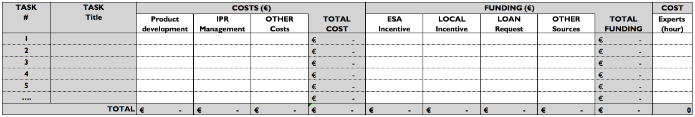
Tab. X: Funding Split

Text

4. Support Request

4.1 Technical Support

Writing Tips: Please define in your own words, what type of Technical Support you request from the ESA BIC in order to develop your product/service. Such support is typically provided as advisory support and is typically related to the use of space technology, data with space origin or methodologies developed within the space engineering domain. Note, the support provider may differ for individual ESA BICs. For guidance, please contact the individual ESA BIC that you apply for before you submit the application.

Text

4.2 Business Support

Writing Tips: Please define in your own words, what type of Business Support you request from the ESA BIC in order to establish and grow your company. Such support is typically provided through coaching and training. Note, the support provider may differ for individual ESA BICs as well as the number of support hours available per applicant. For guidance, please contact the individual ESA BIC that you apply for before you submit the application.

Text

4.3 Office Support

Writing Tips: Please define the number of desk places and further requirements such as laboratory space. Please note that you will typically be required to rent office & lab space, while common facilities at the ESA BIC may be provided free of charge during incubation, such as meeting rooms. For guidance, please contact the individual ESA BIC that you apply for before you submit the application.

Text

