Business Plan

[Name of the company]

[Address of the Company or of the Entrepreneur]

Author:
Date:
Reference: XXXX, Issue XXXX, Version XXXX

Before each paragraph, you will find “writing tips”. Please use these questions as guidelines. Maybe not all questions can be answered, yet. Before starting editing, read the whole template; that will help to write text in the right paragraph and avoid duplicating sentences.

Please limit this Business Plan to maximum 25 pages excluding cover page and excluding the table of contents. To detail and add some more info, add annexes to maximum 15 pages; cf. writing tips in the paragraph “Annexes”.

Remove all blue texts and update the table of contents before saving and submitting the final version.

This business plan is a “living” document, you will update regularly within the incubation phase.

Table of Contents

1. EXECUTIVE SUMMARY 4
2. TEAM BACKGROUND & COMPANY SETUP 4
2.1 The Team 4
2.2 The Company 5
2.3 The Company set-up 5
3. VALUE PROPOSITION 5
4. PRODUCT/SERVICE DESCRIPTION IN DEPTH 5
4.1 The Space Connection 6
4.2 The Technology 6
4.3 The Readiness Level 6
4.4 The Research & Development (R&D) strategy 7
4.5 Intellectual Property 7
5. MARKET ANALYSIS 7
5.1 Context 7
5.2 The Demand 7
5.2.1 Potential figures and trends 7
5.2.2 Analysis and segmentation 8
5.2.3 Field results 8
5.3 The Competition 9
5.3.1 Market penetration 9
5.3.2 Comparative product analysis 9
5.3.3 Competitors business strategy and resources 9
5.4 Growth opportunity / Competitive advantages 9
6. THE BUSINESS MODEL 10
6.1 Communication, distribution, and sales channels 10
6.2 Customer Relationship 10
6.3 Revenue Streams 10
6.3.1. The Price 10
6.3.2. The Revenue 10
6.4 Key Resources 11
6.5 Key Activities 11
6.6 Key Partners 12
7. RISK 12
7.1 SWOT Analysis 12
7.2 Risk Mitigation 12
8. Cost Structure & Financial Projection 13
9. Annexes 15

Reference Documents

RD.1 ESA BIC Austria – Permanent Open Call
RD.2 Instructions for BAP, Evaluation Process and Criteria
RD.3 Draft ESA BIC Austria Incubation Contract
RD.4 Draft Local Incubation Contract
RD.5 Innovation Readiness Levels – March 2015
RD.6 BAP Template – Tables & Figures

EXECUTIVE SUMMARY

Writing Tips: This section is very important! By reading this, the TEB members and Experts should understand at once how your business works and be interested in reading more about it. Having a good business idea is important but showing that you have a clear execution plan, precise goals and the adequate management team to bring the idea to market is key to success.
Try and focus on relevant topics. You have to grab ESA BIC TEB members’ and Experts’ attention with pertinent details.
Don't try to answer all the questions you think people will have, but choose carefully in order to make your project as attractive as possible!

Describe in simple words on maximum 1 page (!):
- Business opportunity foreseen for your products or services, including the space connection):
  - An answer to a problem and the solution you offer using the space connection by your product or service you intend to sell (technology breakthroughs, sales innovation, patent, etc…);
  - Developments: any notable advances and/or the evolution of your state-of-the-art technology, changing needs, new regulations, etc...
- Targeted market;
- Competitive advantages, i.e. where do you differ from similar products or services already on the market – if any;
- Business model; What are your sources of revenue? Do you have any strategic partnerships? How is your offer organized? What is your priority target market? How are your products and services delivered to customers?
- Vision: short-term and long-term vision you have for your company, including growth strategy and resources: what are your short-term goals? (e.g. number of clients, geographical presence, revenue targets...)? What resources will you have available to achieve your goals? What has been done and/or what still needs to be done (e.g. finishing the product, protecting intellectual property, marketing tactics, human and technical resources...)? What is your international growth potential? What is the scalability of your business?
- IPR structure
- Skills set offered by the founder / founding team to make it happen.]

Text

TEAM BACKGROUND & COMPANY SETUP

The Team

Writing Tips: Please provide an introduction and background of the founders and core team members; who is the “leader”? Give a brief resume with 5-10 lines (put CVs in annex). List, if any, the supporters (e.g. support entities, partnerships, advisory board members, financial backers, if any). Remember, we are looking for a visionary entrepreneur and team.

Text

The Company

Writing Tips: Please provide a brief background that presents and substantiates your experience by showing what you have already done; describe the motivation for founding the company and the (intended) shareholding structure. If the company is already registered, please state the date of establishment (not longer than 5 years ago) and provide an extract from the chamber of commerce in the Annex of the Cover Letter.
What are the most significant developments related to the advent of your project?
- Sales activities (significant orders, participation in a "strategic trade show"…)
- Technical production (finished prototypes, creating a pilot unit, establishing a partnership…)
- Other economic or financial activities…
- Human resource structure (recruitment and consolidation of your organization)

Text

The Company set-up

Writing Tips: Please provide a current company set-up in terms of its legal status (e.g. Ltd, BV, GmbH, etc.) and possible shareholders, as well as an excerpt from the Chamber of Commerce where registration of the company is included. In case a company has not yet been established, please provide an envisaged company set-up in terms of its organization, legal status and possible shareholders. Please note that should the evaluation of the proposal be successful and the proposal is selected further for negotiation, the ESA BIC will only finalize and sign a contract with the applicant if the company is set-up according to the legal status as outlined in this section.

Text

VALUE PROPOSITION

Writing Tips: The Value Proposition describes the bundle of products and services that create value for a specific Customer Segment. The Value Proposition is the reason why customers turn to one company over another. It solves a customer problem or satisfies a customer need.

Please state briefly what problems you address, for which customer’s needs, and which solution you offer by your product or service you intend to sell. State briefly your Unique Selling Proposition, i.e. why your product or service will add more value to the customer than other similar offerings. Values may be quantitative (e.g. price, speed of service) or qualitative (e.g. design, customer experience). Please give an example of an application of your product.

Text

PRODUCT/SERVICE DESCRIPTION IN DEPTH

The Space Connection
Writing Tips: The space connection is very important since it qualifies your start-up or project to apply to an ESA BIC. Failing to show a strong space connection is eliminatory.
Describe which space technology or system you are using for your product or service. Provide evidence that you have access to this technology. Provide a more extensive and precise description of how you are integrating the space technology or system into your product or service.
Note that only applications of space systems or the use of space technologies with a high degree of innovation will be selected.
- If you are processing Earth Observation satellites system data, which system(s) and spectrum are you using and why, and how do you get the data? Which quality is required (e.g. spatial resolution, temporal frequency, radiometric characteristics, availability etc.). Which other non-space data is required? The detailed specification of the core datasets can be found in the Copernicus Space Component Data Access, available under http://gmesdata.esa.int/web/gsc/dap_document
- If you receive GNSS signals, which system(s) are you using? Do you need Galileo for a better location and/or resolution? If you use EGNOS, do you plan to use Sysnet?
- If you receive Telecommunications System signals, which system(s) are you using? Why? Did you make a trade-off between various systems (technical and budget wise)?
- If you transfer a space technology, detail which one and how it has been developed and used in the space sector (provide references).
- If you have access to intellectual property, explain how: through ownership, licensing or simply because it is publically available? Provide references.

Text

The Technology

Writing Tips: Please provide an in-depth description of the technology needed for your product/service; explain the state-of-the-art technology that provides the innovative foundation of your project. Remember that you are also addressing non-specialists (bankers, managers, etc.), and that you must keep your explanation simple and concise.
What are some of the main technical terms used to describe your offer? What is the current state-of-the-art technology in your field? Point out some recent advances and their influence on the market. What are the perspectives for technological evolution, and in what time frame? Are there any other known projects or technical developments in progress that may have a strong influence on your future technological context?

Text

The Readiness Level

Writing Tips: In which development stage is the technology at the moment as well as your product/service? What is the maturity of your product/service? E.g. are all components available of-the-shelf and it is a matter of assembling. Or in case of services, e.g. what is the level of programming needed to turn the service idea into a real application. Please also state the current Innovation Readiness Level as well as which level you intend to reach at the end of the incubation phase. Use the Innovation Readiness Level overview (RD.5) as provided in the application package.

Text

The Research & Development (R&D) strategy

Writing Tips: Please include information on the materials/software/data needed, the strategy to acquire these (what is done in-house or by external partners), as well as the estimated development time. Also, address any critical issues still to be solved associated with your product development (partial or total failure, missing calendar targets, over-spending.

Text

Intellectual Property

Writing Tips: Please mention any patents you own or licenses you have acquired for your product/service (if necessary, annex evidence of the filed patent or trademark). For how long will they be valid? Who holds the patent(s)? What geographical zones are covered by the patent(s)? If you are contracting to use a patent from outside your own company, what are the contractual clauses (exclusivity, geographical zones, period of time, etc.)? What budget issues are related to industrial and intellectual property (cash payments, royalties, payment terms)?
If you don’t own any IP yet, but envisage getting some, please explain your strategy.
In case of non-patentable knowledge, please explain your strategy to protect your product or service idea (market gain, trade secrets etc.) and any planned patenting activities should this be needed.

Text

MARKET ANALYSIS

Context

Writing Tips: Describe the global context (regulatory, political, sociological, etc.) surrounding your company, as well as the main trends and other factors that could affect your business (both in positive and negative ways).
Describe the environment and constraints over which you may have little or no influence, such as demographic trends, lifestyles, interest groups, legal aspects, exchange rates.
Is your business sector regulated? Is regulation harmonized internationally? Are there existing standards? Are they mandatory? Are there a lot of them? Is your business sector sensitive to cultural trends (such as "bio" or organic food products)? Is it subject to pressure from interest groups, either in favour or against your own position?

Text

The Demand

Potential figures and trends

Writing Tips: Evaluate the current global market, both in actual terms (real quantities sold) and/or potential terms (quantities that could be sold). Make sure to include market value, volume, and expected growth. Consider expressing your company's market share (as a percentage) in the long run.
What is the volume and current value of the target market? Indicate its progression over time? Is yours a potential market (watch out if you're the first one in it...), emerging, growing, mature, or declining? Show market coverage by product type, by customer segments, by geographical sector (own country, EU, USA, etc.). How did you gather your data? How reliable is it? Can you give upper and lower forecasts?

Text

Analysis and segmentation

Writing Tips: Understand and present how the company's target market(s) operate(s) -- that is, the relationship between the company and its customers. Break the market down into several coherent segments in order to properly adapt your company's marketing strategy to one or more of those segments.

Note: this is related to your analysis of the situation based on the market study if you already performed one, but also on the company's strategy to enter that market (which you will present later in this document).

How does the market function? Are there conditions for entering it (regulations, authorizations, patents, exclusive contracts...)? How is the market segmented (i.e. what are the unified sub-markets)? What criteria and which segmentation methods did you choose: demographic, geographic, socio-economic, lifestyle, behavioural, and/or psychological attitudes towards your product?

Describe each segment in terms of: buying patterns, payment conditions, solvency, resistance to change, decision processes, decision cycles, etc. For the highest priority sectors, indicate relevant segmentation criteria such as: age, sex, revenue, risk, technology, synergy, size, competition,...

Text

Field results

Writing Tips: If users have tested your product or service, show the outcome. Give an analysis of serious prospects: why are they interested? Did users express any thoughts on how the product could evolve or be improved (users often suggest unexpected ideas)? What price (psychological price) are they ready to pay? Take advantage of negative results as well: why were some people not interested? Gather their objections; they may be very useful for you in developing sales arguments.

Text

The Competition

Market penetration

Writing Tips: Evaluate the power of your competition in the target market, whether it is direct, indirect, immediate, or theoretical.
Are there any competitors who sell the same product or a similar one? How many competitors are there? How big are they? Are they very active? What are their market shares? How has their market share changed recently? Is there any trustworthy information regarding the arrival of new competitors in the near future (new product announcements, press leaks, personal information)?

Text

Comparative product analysis

Writing Tips: Analyse your competitors' products. Estimate the degree of satisfaction these products generate with respect to market needs.
Which products currently meet customer expectations for the need you intend to address? (identical products and/or those based on other technologies). What are their main characteristics: price, quality, delivery speed, and technical support? How are the products distributed? Can you place your technology and competing technologies on a life-cycle graph? If your product is totally new, is the market need currently being met by something else? To what degree? How?

Text

Competitors business strategy and resources

Writing Tips: Who are your competitor's customers and suppliers? How do they operate and how are they organized? Sales force, distribution channels, resellers, decision cycles, communication budgets... Who are their shareholders? Do you have any information on their profitability? How will they react to your entry into the market? What are their strong and weak points?

Text

Growth opportunity / Competitive advantages

Writing Tips: Show that there is a window of opportunity for your project in the market context that you have described (environment + market + competition), and explain it. Show the commercial breakthrough capacity of your product or service.
What needs are not being addressed properly by the competition? What are the latent needs you wish to meet? What new uses are you going to enable? How is your offer different from the competition? What will your competitive advantage be (technology break-through, marketing position, know-how…)? What is the scalability of your business case to achieve international growth (diversification in other market sectors and countries).

Text

THE BUSINESS MODEL

Writing Tips: A business model describes the rationale of how an organization creates, delivers, and captures value.

Communication, distribution, and sales channels

Writing Tips: The Channels describes how a company communicates with and reaches its Customer Segments to deliver a Value Proposition.
How do you raise awareness about our company’s products and services? Through which Channels do your Customer Segments want to be reached? How are you reaching them now? How are your Channels integrated? Which ones work best? Which ones are most cost-efficient? How are you integrating them with customer routines?

Text

Customer Relationship

Writing Tips: What type of relationship does each of your Customer Segments expect you to establish and maintain with them? Which ones have you already established? How are they integrated with the rest of your business model? How costly are they?
Possible examples are: Personal assistance, Dedicated Personal Assistance, Self-Service, Automated Services, Communities, Co-creation.

Text

Revenue Streams

The Revenue Streams represents the cash a company generates from each Customer Segment (costs must be subtracted from revenues to create earnings)

The Price

Writing Tips: How do you expect to make money and explain your pricing strategy, i.e. what do you expect your customers are willing to pay? What and how do they recently pay? How would they prefer to pay?

Text

The Revenue

Writing Tips: If you have multiple revenue streams, e.g. a product combined with a recurring service, how much does every revenue stream contribute to the overall revenues? Does your revenue forecast demonstrate increased profitability toward the end of the forecast period?

Additional tips:
Asset sale: selling ownership rights to a physical product
Usage fee: generated by the use of a particular service – the more used the more to be paid (e.g. telecom operator, hotel charges, package delivery of parcel
Subscription fees: selling continuous access to access (e.g. gym)
Lending/Renting/Leasing: temporarily granting someone the exclusive right to use a particular asset for fixed period in return for a fee; benefits incurring expenses for only a limited time rather than bearing the full cost (e.g. car-sharing services)
Licencing: permission to use protected IP in exchange for licencing fees; allows rights holder to generate revenues from their property
Brokerage fees: intermediation services performed on behalf of 2 or more parties (e.g. Credit card providers, brokers and real estate, etc.)
Advertising: fees for advertising a particular product, service, or brand]

Text

Key Resources

Writing Tips: The Key Resources paragraph describes the most important assets required to make a business model work. Every business model requires Key Resources. These resources allow an enterprise to create and offer a Value Proposition, reach markets, maintain relationships with Customer Segments, and earn revenues.
Describe your Key Resources (they can be categorized as follows: Physical, Intellectual, Human, Financial). Detail which production capacity do you have or expect to acquire?
To grow your business, what assets (IP and infrastructure) and human resources do you expect to get into your company and when? Provide a growth projection over the next 3 years (also included in the Profit & Loss Projection in Paragraph 8).

Text

Key Activities

Writing Tips: The Key Activities paragraph describes the most important things a company must do to make its business model work. These are the most important actions a company must take to operate successfully. Like Key Resources, they are required to create and offer a Value Proposition, reach markets, maintain Customer Relationships, and earn revenues.

Describe your Key Activities, which can be categorized as follows: Production (relate to designing, making, and delivering a product in substantial quantities and/or of superior quality); Problem solving (relate to coming up with new solutions to individual customer problems); Platform/network.

Describe the supply chain and your position within it. Who are your key partners and suppliers? Which of the key resources do they provide for you? What key activities do they perform for you? Provide a diagram showing the relationship. What partnerships will you need to develop during incubation?

Text

Key Partners

Writing Tips: The Key Partnerships Paragraph describes the network of suppliers and partners that make the business model work. Companies forge partnerships for many reasons, and partnerships are becoming a cornerstone of many business models. Companies create alliances to optimize their business models, reduce risk, or acquire resources.
Describe your key partners, which can be categorized as follows: Strategic alliances between non-competitors, “Coopetition”: strategic partnerships between competitors, Joint ventures to develop new businesses, Buyer-supplier relationships to assure reliable supplies.

Text

RISK

SWOT Analysis

Writing Tips: Please describe the strengths and weaknesses of your company; e.g. a strong IP basis, an experience team with an extensive track record; or the contrary, e.g. the lack of a certain area of expertise or no prior experience with the supplier network you would need for your business.
Also describe the external opportunities or threats you may encounter, e.g. the right timing for the market you are addressing or the fierce competition currently present.

Text

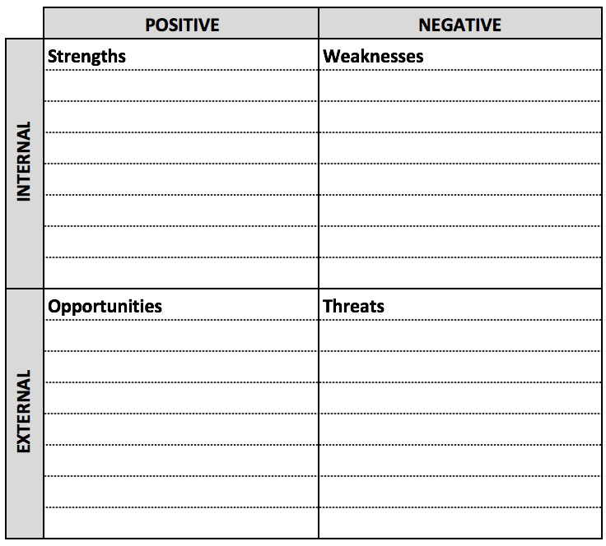
Fig. X: SWOT Analysis [template]

Risk Mitigation

Writing Tips: Please provide a list of all risks involved when setting up/growing your business in the incubation phase and beyond. Include a mitigation plan per identified risks, i.e. how likely is it that the risk indeed turns into a problem and how to solve the problem once it occurs. For this, please use the Risk Analysis table.

Text

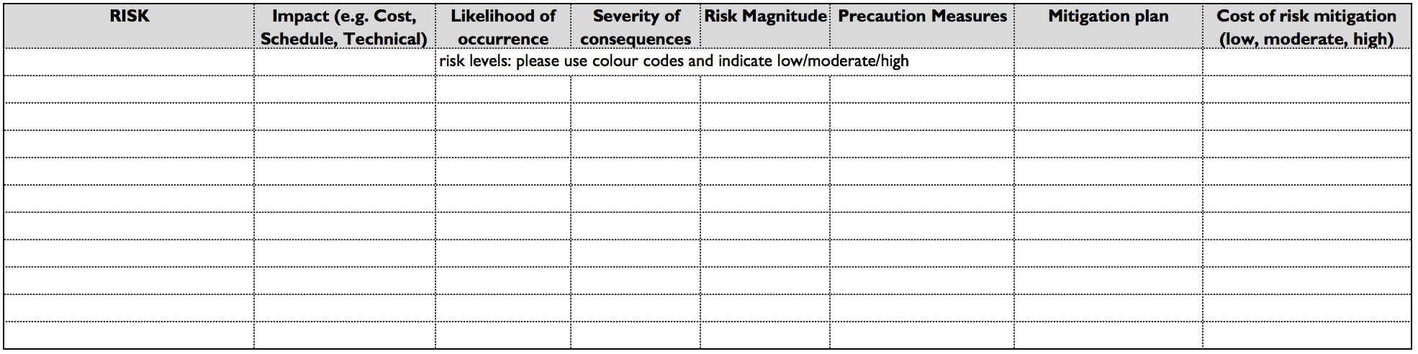
Fig. X: Risk Analysis [template]

Cost Structure & Financial Projection

Writing Tips: What are the most important costs to operate the business? What are the most expensive key activities and resources? What are your fixed costs? What are your variable costs? Calculate your total cost for the next 3 years and if already operational also include the cost of last year. Provide all assumptions to compute the Profit & Loss projections.
Please provide a Profit & Loss projection including the above information and using the P&L table contained in the Excel file attached to this application package (RD.6). Please, fill-in the white cells with your data in the following P&L scheme:

- Sales Revenue (or Turnover) refers to the income that the company receives from its normal business activities, usually from the sale of goods and services to customers.
- Direct cost of Sales (or Cost of Sales) refers to the total of all direct costs involved in preparing each company’s product/service for sale.
- Gross Profit (or Sales Profit) refers to the difference between sales revenue and the direct cost of sales.
- Operating Expenses (or OPEX) refer to the expense incurred in carrying out the company’s day-to-day activities, but not directly associated with production of goods and/or services.
- Income from Operations refers to the money value generated from running the primary business and it excludes income from other extraordinary sources.
- Other Income refers to the income derived from extraordinary transactions not involved in daily operations of the company business.
- Net Profit refers to the company's total earnings.

Text

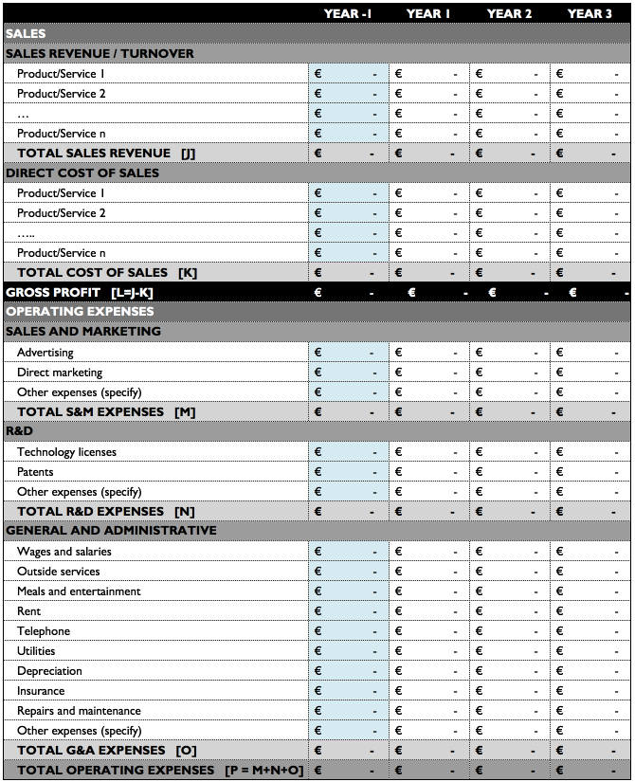
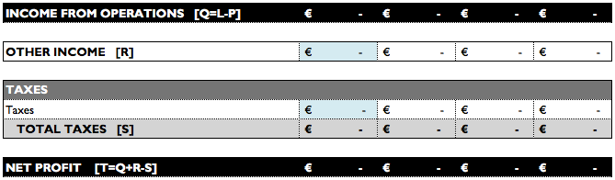
Tab. X: Profit & Loss Projection [template]

Annexes

Writing Tips: To detail and/or add information relevant to the proposal, add annexes to a maximum of 15 pages. These may contain, for instance:
- Curricula Vitae (CVs) of the key team members
- Market Studies summaries
- Current Tenancy Agreement including notice period, if applicable
- References of publications
- Letters of Support/Interest/Commitment from potential/existing customers, Memoranda of Understanding (MoUs) with partners/suppliers
- Recent accounting report
- Patents filed, technical details
- Recent accounting reports
- Flyers, brochures and other promotional materials
- Etc.

Text

